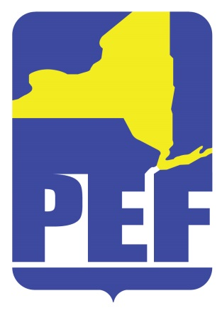
PEF REGION 8 POLITICAL ACTION COMMITTE
January 11, 2022
Zoom Meeting 6.pm.

- CALL TO ORDER

- ACCEPTANCE OF AGENDA

- APPROVAL OF MINUTES

- REGION COORDINATOR COMMENTS

- LEGISLATIVE UPDATE

  - Possibility of forming endorsement committee

- QUESTIONS

- ADJOURN

