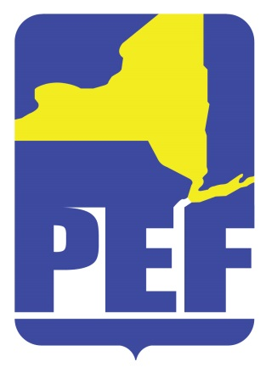
PEF REGION 8 POLITICAL ACTION COMMITTE
February 8, 2022
Zoom Meeting 6.pm.

- CALL TO ORDER

- ACCEPTANCE OF AGENDA

- APPROVAL OF MINUTES

- REGION COORDINATOR COMMENTS

- PAC RULES – REGION 8

- LEGISLATIVE BREAKFAST

- LOBBYING ISSUES

  - Environmental Health Staffing
  - SWPAC Issues

- QUESTIONS

- ADJOURN

