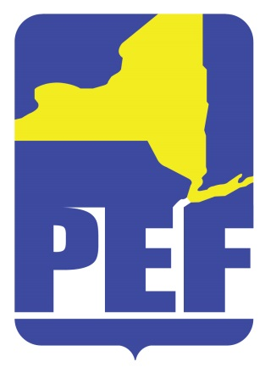
PEF REGION 8 POLITICAL ACTION COMMITTE
March 8, 2022
Zoom Meeting 6.pm.

- CALL TO ORDER

- ACCEPTANCE OF AGENDA

- APPROVAL OF MINUTES

- REGION COORDINATOR COMMENTS

- PAC CREDENTIALED MEMBERS

- LEGISLATIVE BREAKFAST

- QUESTIONS

- ADJOURN

