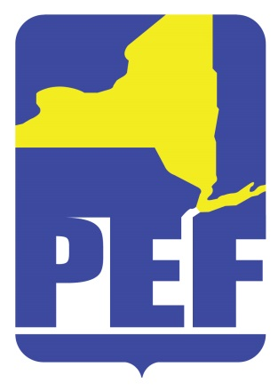
PEF REGION 8 POLITICAL ACTION COMMITTE
May 17, 2022
Zoom Meeting 6.pm.

- CALL TO ORDER

- ACCEPTANCE OF AGENDA

- APPROVAL OF MINUTES

- REGION COORDINATOR COMMENTS

- GUEST – ANGELO SANTABARBARA

- CANDIDATE VOTES

- PAC RULES (CREDENTIALED MEMBERS STATUS)

- COMMITTEE FOR RULES (3 NEW APPOINTEES; 2 actives, 1 retiree)

- PAC PAL DISCUSSION

- QUESTIONS

- ADJOURN

