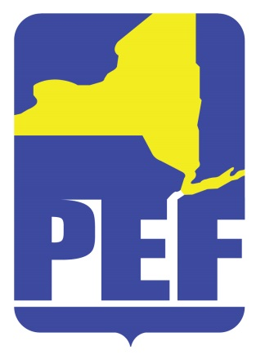
PEF REGION 8 POLITICAL ACTION COMMITTE
June 14, 2022
Zoom Meeting 6.pm.

- CALL TO ORDER

- ACCEPTANCE OF AGENDA

- APPROVAL OF MINUTES

- REGION COORDINATOR COMMENTS

- PAC RULES (COMMITTEE UPDATE - BRIEF)

- CANCELING OF JULY MEETING (NO MEETINGS IN AUGUST)

- QUESTIONS

- ADJOURN

