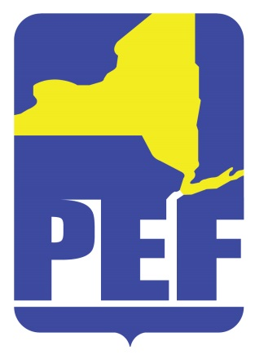
PEF REGION 8 POLITICAL ACTION COMMITTE
August 9, 2022
SPECIAL EDORSEMENT MEETING
Zoom Meeting 6.pm.

- CALL TO ORDER

- ACCEPTANCE OF AGENDA

- ACCEPTANCE OF REVISED MAY MINUTES

- CANDIDATE ENDORSEMENTS

  - NYS District 41
  - US Congress NY District 20

- QUESTIONS

- ADJOURN

