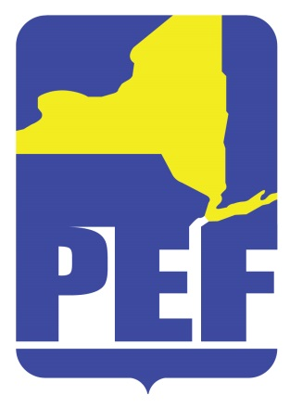
PEF REGION 8 POLITICAL ACTION COMMITTE
September 1, 2022
SPECIAL EDORSEMENT MEETING
Zoom Meeting 6.pm.

- CALL TO ORDER

- ACCEPTANCE OF AGENDA

- CANDIDATE INTERVIEWS (6:15 p.m. – 8:15 p.m.)

- CANDIDATE ENDORSEMENTS

  - NYS Assembly Districts 108, 109, 110, 112, 113, 114
  - NYS Senate Districts 43, 44, 46, 51
  - US Congress NY District 21

- QUESTIONS

- ADJOURN

