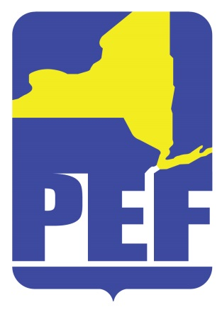
PEF REGION 8 POLITICAL ACTION COMMITTE
September 13, 2022
Zoom Meeting 6.pm.

- CALL TO ORDER

- ACCEPTANCE OF AGENDA

- APPROVAL OF MINUTES

- REGIONAL COORDINATOR COMMENTS

- PAC RULES (COMMITTEE UPDATE - BRIEF)

- PAC HOLIDAY DINNER

- QUESTIONS

- ADJOURN

